1. **Creating a Project**

* Open Xcode from launchpad

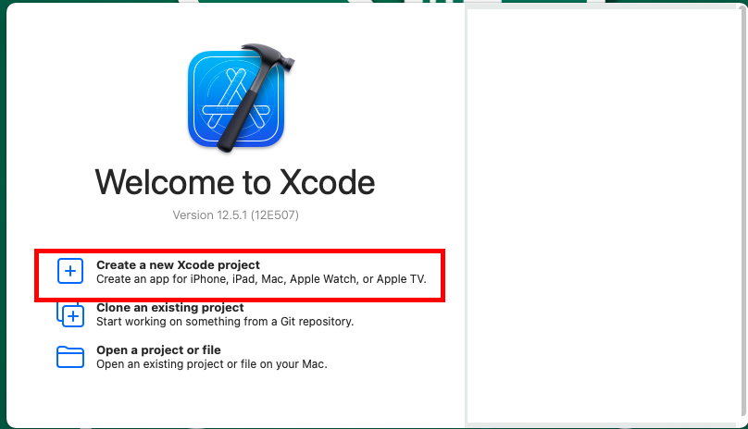

1. **Choosing template for the project**

* Select **iOS** at the top
* Make sure the application is **App**
* Select **Next**

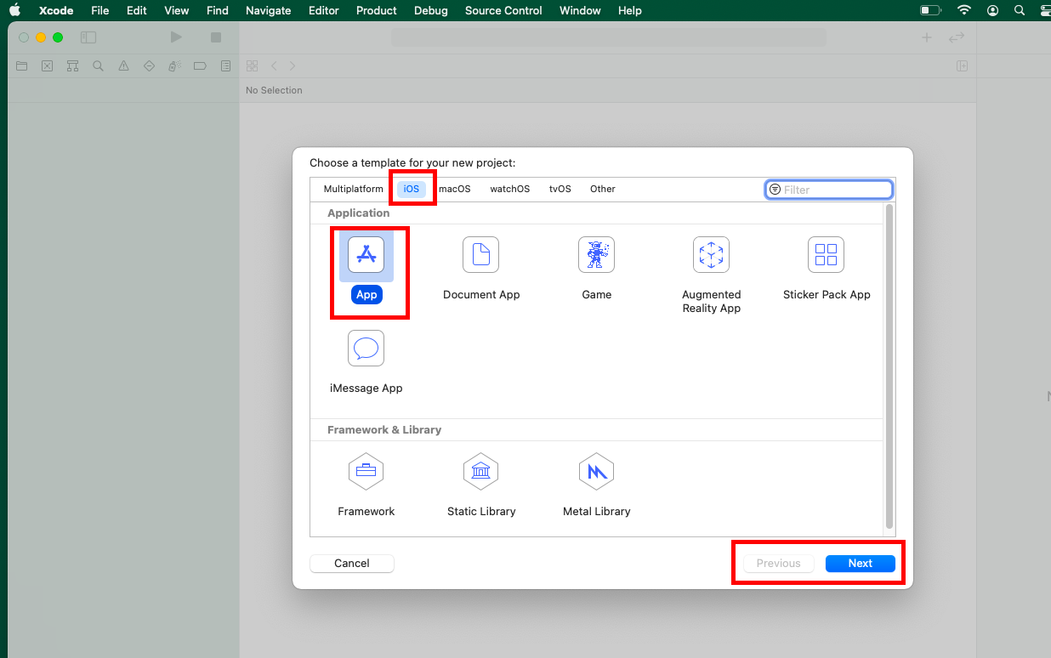

1. **Choosing options for your project**

* Give a name for your application based on the assignment
* Select Interface as **Storyboard**
* Select Life cycle as **UIKit App Delegate**
* Select Language as **Swift**
* Click Next
* Uncheck **Use Core Data** and **Include Tests**

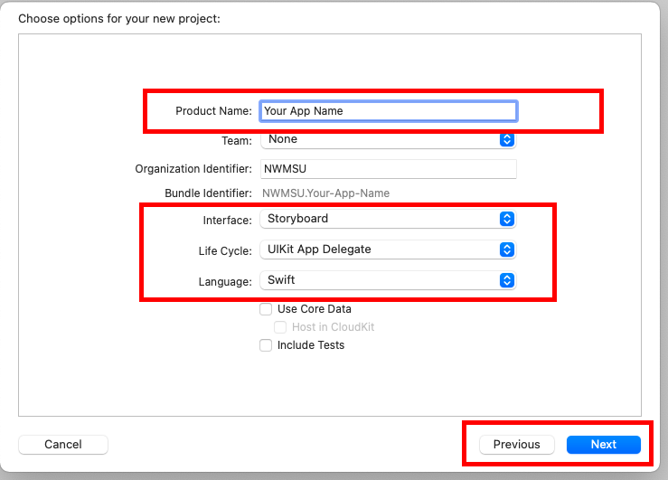

1. **Saving project in local folder**

* Save the project at your desired location on the PC
* Uncheck create git repository
* You may also create a new folder and save it there.
* Click on Create

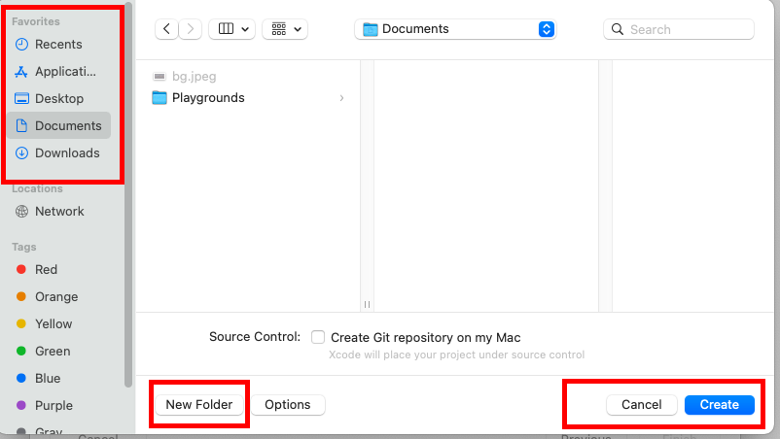

1. **Preview of the application**

* If necessary modify the **display name**. This name shows for the app when it is launched in a phone.
* All the files of your application will be seen in the **project navigator**

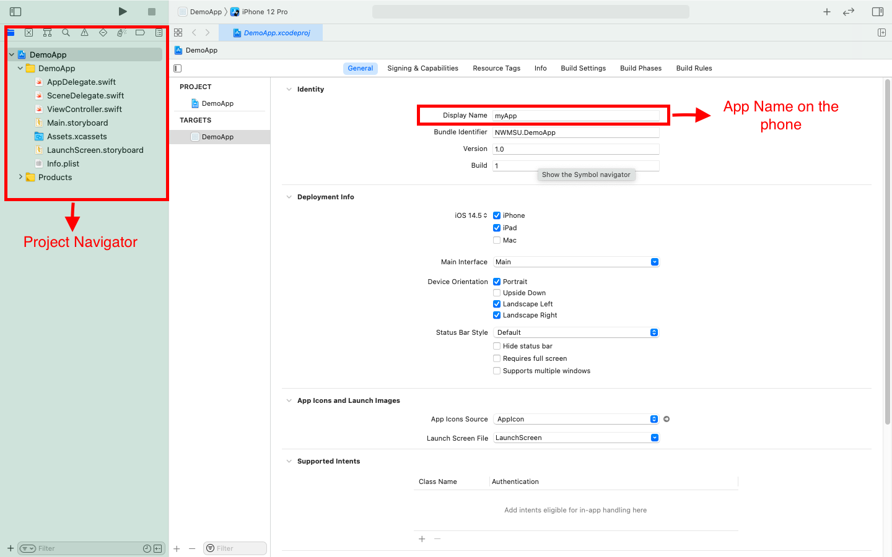

1. **Components of Xcode**

* Document inspector shows the various objects (Buttons, labels etc.,) used inside the app
* Select the device type of your choice for launching the app
* Select the device of your choice to design
* Make Sure the app you run and design is same (Ex: iPhone 12 pro max etc.,)

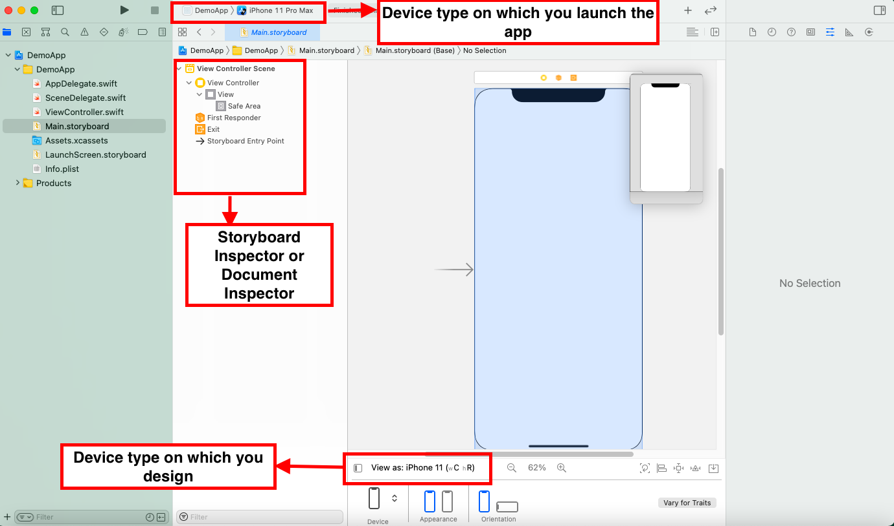

1. **Library**

* Add different objects for your app from the library using + icon on the header.

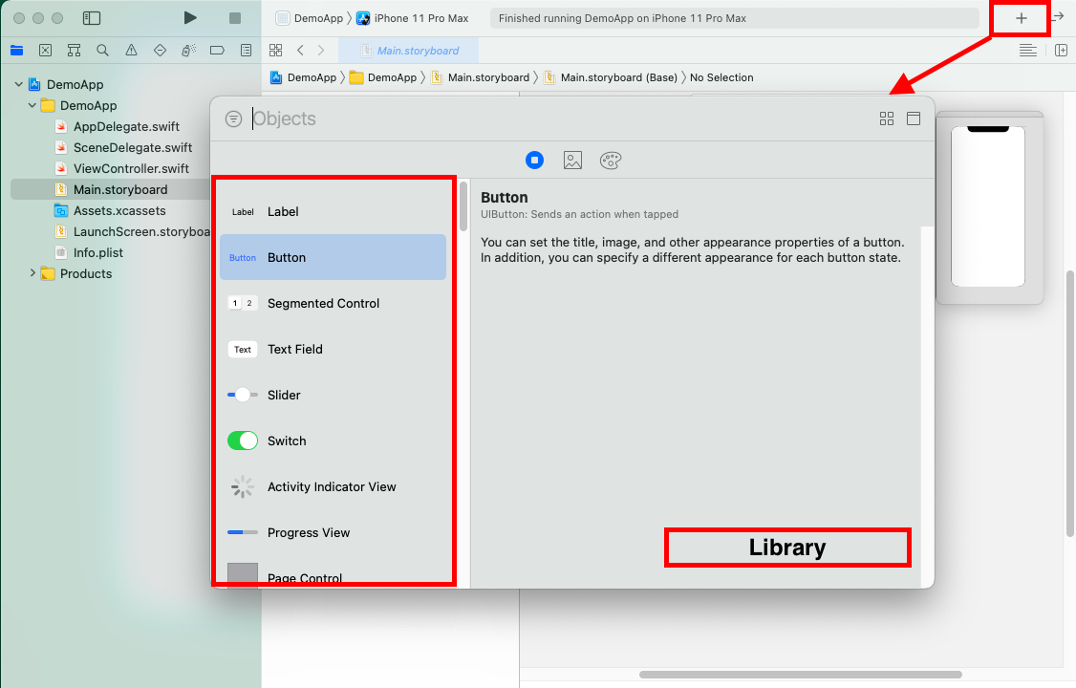

1. **Attribute Inspector**

* Select the required object from the library and drag it to the storyboard
* You will see all the properties of that particular object in the attribute inspector. Modify the text, font size, background color etc., appropriately.
* You will see attribute inspector only when you select it either from Document inspector or storyboard.

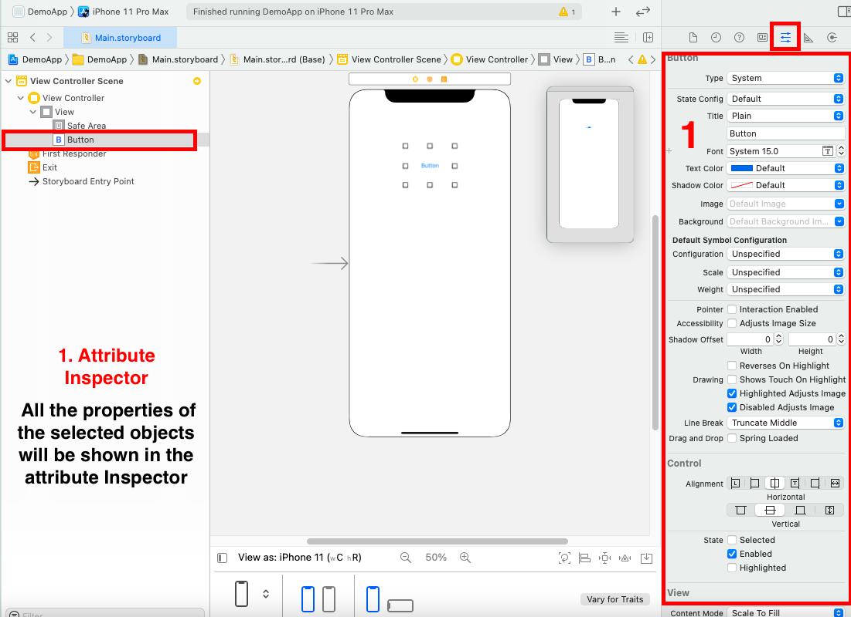

1. **Creating connections for the objects**

* Use **option** key on the keyboard to open view controller file and **storyboard.main** side by side.
* **Control drag** the button to view controller
* On the prompt give a name for the object. If your creating the object reference select connection as **Outlet**. If creating an event on the object use **Action** from the dropdown.
* Make sure you keep all variable declarations above **viewDidLoad ()** function and all actions below the **viewDidLoad ()** method (It’s not mandatory but recommended structure for an app)
* Give an appropriate name for the object denoting its function or property
* Click on connect

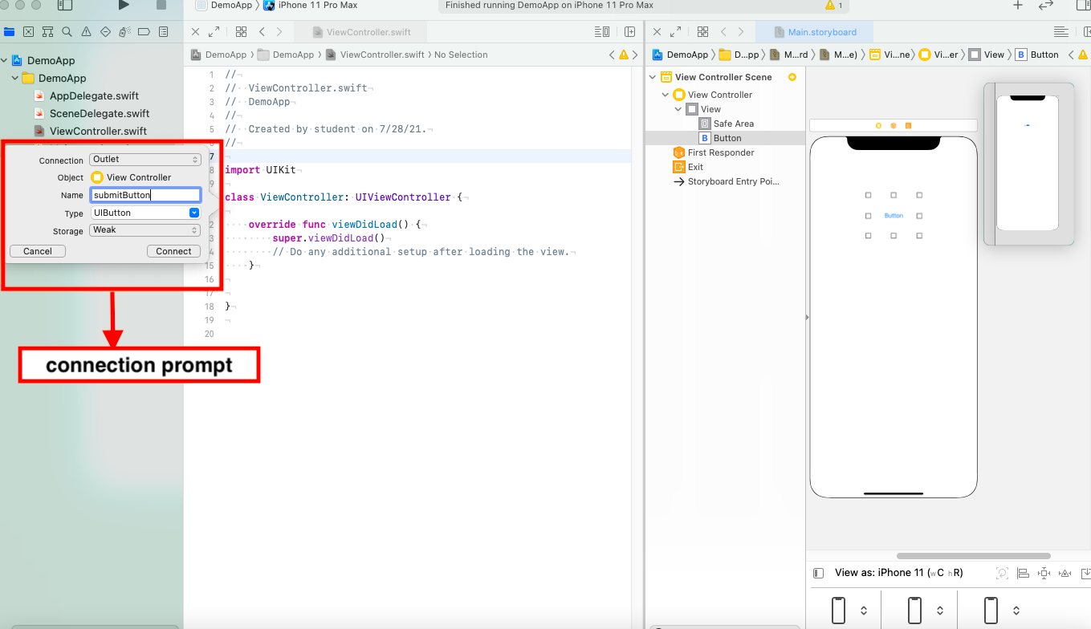

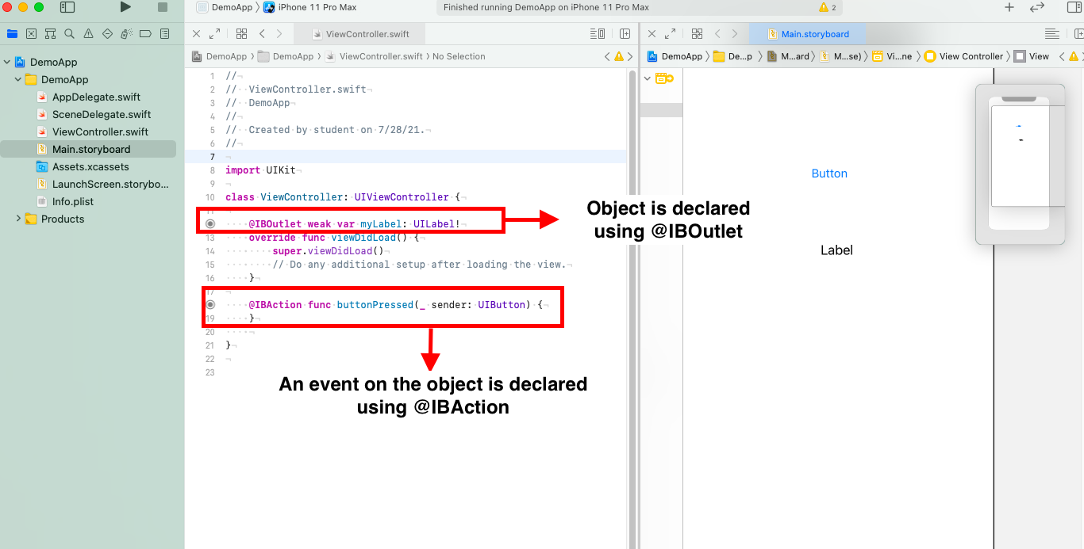

1. **Checking for Correctness of Connections**

* Sometimes wrong Connection between storyboard and controller may go wrong so we should make sure everything is correct.
* We can check connections in **Connection Inspector.**
* We need to remove connections from the inspector only. This will not crash the application else multiple connections will be made and result in app crash.

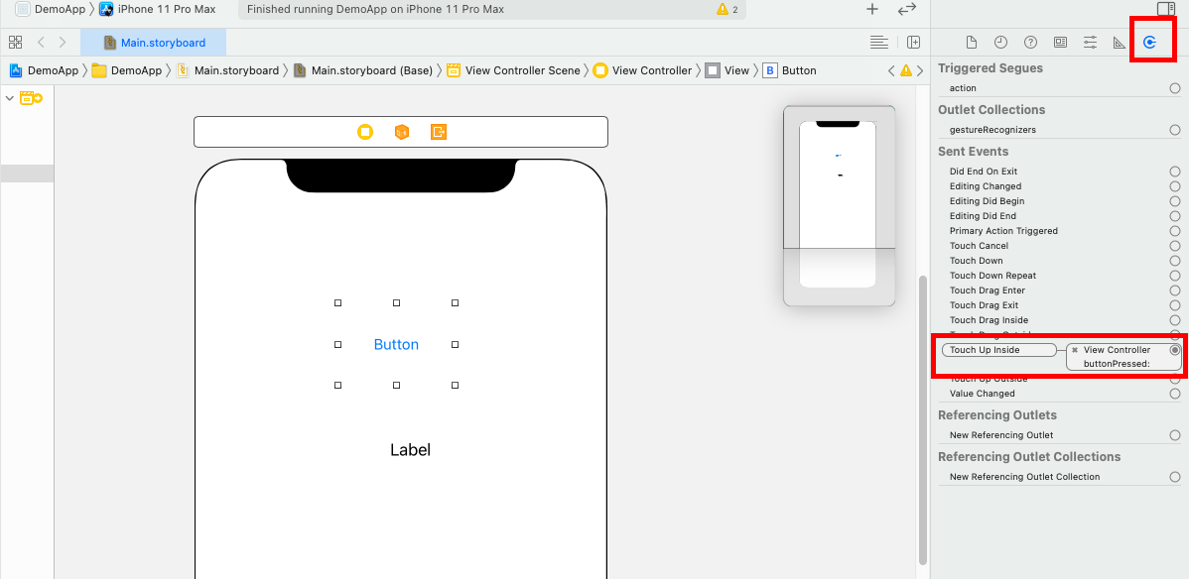

[**https://docs.swift.org/swift-book/documentation/the-swift-programming-language/thebasics/**](https://docs.swift.org/swift-book/documentation/the-swift-programming-language/thebasics/)